CAPSTONE PROJECT-1
SQL
HOSPITAL MANAGEMENT SYSYTEM

DONE BY
KIRUTHIK.A

CONTENTS

TABLE OF THE CONTENTS
CHAPTER | TITLE | PAGE NO.
1 | INTRODUCTION | 1
 | 1.1 OVERVIEW OF THE PROJECT | 1
 | 1.2 OBJECTIVES OF THE PROJECT | 1
 | 1.3 ORGANIZATION PROFILE | 2
2 | SYSTEM ANALYSIS | 3
 | 2.1.PROBLEM DEFINITION | 3
 | 2.2.PROPOSED SOLUTION | 3
3 | SYSTEM DESIGN AND DEVELOPMENT | 4
 | 3.1 ER DIAGRAM | 4
 | 3.2 DATA SCHEMA | 5
 | 3.3 ADVANTAGES OF THE SYSTEM | 6
4 | SOURCE CODE | 7
5 | TASK | 21
6 . CONCLUSION 47

1.INTRODUCTION

1.1.OVERVIEW OF THE PROJECT

The Hospital Patient Management System (HPMS) is designed to digitize and streamline the management of hospital operations, replacing manual paperwork and outdated digital records. It centralizes patient records, doctor information, diagnoses, prescriptions, billing, and room allocations into a secure database. By integrating these processes, the system ensures real-time access, accuracy, confidentiality, and efficiency across all departments, ultimately improving patient care and operational workflow.

1.2.OBJECTIVE OF THE PROJECT

To develop a reliable and secure database system for hospital
To provide a real-time and secure to patient and staff data.
To reduce human errors in appointment scheduling,billing and patient record handling.
To ensure data confidentiality and integrity in compliance with healthcare standards.
To automate hospital process such as alerts,inventory updates and billing adjustments.
To support scalability for managing high volumes of patients and treatments.

1.3.ORGANAISATION PROFILE

The NIIT Group is a leading digital talent development organization and a premier provider of managed training services, dedicated to building skilled human capital and enhancing workforce talent globally. Established in 1981 to help the nascent IT industry overcome its human resource challenges, the NIIT Group ranks among the world’s leading training organizations due to its vast and comprehensive array of talent development programs. With a footprint in over 10 countries, NIIT Group delivers learning interventions that create superior outcomes. The group comprises NIIT Limited (NIIT) and NIIT Learning Systems Limited (NIIT MTS).
NIIT’s Corporate Learning business has been transferred to NIIT MTS via a composite scheme of arrangement in May 2023. The reorganization helps NIIT create a sharper focus on its Skills & Careers Business which delivers a diverse range of learning and talent development programs to thousands of early career and working professionals to accelerate career success across futuristic domains including technology and banking.

SYSTEM ANALYSIS

2.1. PROBLEM DEFINITION

Hospitals using manual or outdated systems face:
- Misplaced patient records.
- Appointment clashes.
- Inefficient billing processes.
- Lack of real-time resource tracking.
- Poor coordination between staff and departments.

2.2. PROPOSED SOLUTION

The HPMS centralizes hospital operations into a database-driven system with:
- Secure storage of patient and staff data.
- Automated billing updates during admissions and discharges.
- Integration of prescriptions with pharmacy inventory.
- Automatic alerts for critical conditions or missed appointments.

SYSTEM DESIGN AND DEVELOPMENT

3.1.ER DIAGRAM

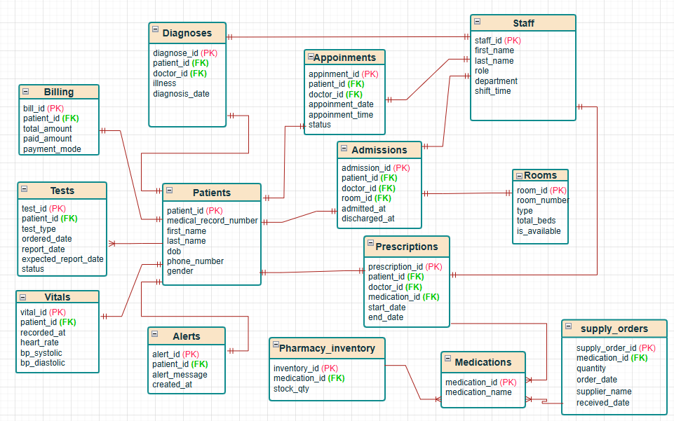

3.2. DATA SCHEMA

The database schema consists of the following main entities:
- Patients
- Staff
- Appointments
- Admissions
- Rooms
- Diagnoses
- Medications
- Prescriptions
- Pharmacy Inventory
- Tests
- Billing
- Alerts
- Supply Orders
- Vitals

3.3. ADVANTAGES OF THE SYSTEM

- Reduces medical errors and duplicate entries.
- Saves time for doctors and administrative staff.
- Provides transparency in billing and records.
- Enhances patient care with timely alerts.
- Efficient use of hospital resources.

APPENDICES

SOURCE CODE

create database hospital;
use hospital;

CREATE TABLE patients (
patient_id INt AUTO_INCREMENT PRIMARY KEY,
medical_record_number VARCHAR(20) UNIQUE NOT NULL,
first_name VARCHAR(50) NOT NULL,
last_name VARCHAR(50) NOT NULL,
dob DATE NOT NULL,
phone_number varchar(12) unique check(length(phone_number)=10),
gender varchar(1) CHECK (gender IN ('M','F','O'))
);

CREATE TABLE staff (
staff_id INT AUTO_INCREMENT PRIMARY KEY,
first_name VARCHAR(50) NOT NULL,
last_name VARCHAR(50) NOT NULL,
role VARCHAR(20) CHECK (role IN ('Doctor','Nurse','Admin')),
department VARCHAR(50) NOT NULL
);

CREATE TABLE rooms (
room_id INT AUTO_INCREMENT PRIMARY KEY,
room_number VARCHAR(10) UNIQUE NOT NULL,
type VARCHAR(20) CHECK (type IN ('ICU','General','Private')),
total_beds INT NOT NULL,
is_available BOOLEAN DEFAULT TRUE
);

CREATE TABLE appointments (
appointment_id INT AUTO_INCREMENT PRIMARY KEY,
patient_id INT NOT NULL,
doctor_id INT NOT NULL,
appointment_date DATE NOT NULL,
appointment_time TIME NOT NULL,
status VARCHAR(15) DEFAULT 'Scheduled' CHECK (status IN ('Scheduled','Completed','No-show')),
FOREIGN KEY (patient_id) REFERENCES patients(patient_id) ON DELETE CASCADE,
FOREIGN KEY (doctor_id) REFERENCES staff(staff_id) ON DELETE CASCADE
);

CREATE TABLE admissions (
admission_id INT AUTO_INCREMENT PRIMARY KEY,
patient_id INT NOT NULL,
doctor_id INT NOT NULL,
room_id INT NOT NULL,
admitted_at DATE NOT NULL,
discharged_at DATE,
FOREIGN KEY (patient_id) REFERENCES patients(patient_id) ON DELETE CASCADE,
FOREIGN KEY (doctor_id) REFERENCES staff(staff_id) ON DELETE CASCADE,
FOREIGN KEY (room_id) REFERENCES rooms(room_id)
);

CREATE TABLE diagnoses (
diagnosis_id INT AUTO_INCREMENT PRIMARY KEY,
patient_id INT NOT NULL,
doctor_id INT NOT NULL,
illness VARCHAR(100) NOT NULL,
diagnosis_date DATE NOT NULL,
FOREIGN KEY (patient_id) REFERENCES patients(patient_id) ON DELETE CASCADE,
FOREIGN KEY (doctor_id) REFERENCES staff(staff_id)
);

CREATE TABLE medications (
medication_id INT AUTO_INCREMENT PRIMARY KEY,
medication_name VARCHAR(100) NOT NULL
);
CREATE TABLE prescriptions (
prescription_id INT AUTO_INCREMENT PRIMARY KEY,
patient_id INT NOT NULL,
doctor_id INT NOT NULL,
medication_id INT NOT NULL,
start_date DATE NOT NULL,
end_date DATE,
FOREIGN KEY (patient_id) REFERENCES patients(patient_id) ON DELETE CASCADE,
FOREIGN KEY (doctor_id) REFERENCES staff(staff_id),
FOREIGN KEY (medication_id) REFERENCES medications(medication_id)
);

CREATE TABLE pharmacy_inventory (
inventory_id INT AUTO_INCREMENT PRIMARY KEY,
medication_id INT NOT NULL,
stock_qty INT NOT NULL,
FOREIGN KEY (medication_id) REFERENCES medications(medication_id)
);

CREATE TABLE tests (
test_id INT AUTO_INCREMENT PRIMARY KEY,
patient_id INT NOT NULL,
test_type VARCHAR(50) NOT NULL,
ordered_date DATE NOT NULL,
report_date DATE,
expected_report_date DATE, -- NEW COLUMN
status VARCHAR(15) DEFAULT 'Pending' CHECK (status IN ('Pending','Completed')),
FOREIGN KEY (patient_id) REFERENCES patients(patient_id) ON DELETE CASCADE
);
-- alter table tests add column expected_report_date DATE AFTER report_date;

CREATE TABLE billing (
bill_id INT AUTO_INCREMENT PRIMARY KEY,
patient_id INT NOT NULL,
total_amount DECIMAL(10,2) NOT NULL,
paid_amount DECIMAL(10,2) DEFAULT 0,
payment_mode VARCHAR(25) CHECK(payment_mode IN ('E_wallet','G_Pay','Cash')),
FOREIGN KEY (patient_id) REFERENCES patients(patient_id) ON DELETE CASCADE
);

CREATE TABLE alerts (
alert_id INT AUTO_INCREMENT PRIMARY KEY,
patient_id INT,
alert_message TEXT,
created_at TIMESTAMP DEFAULT CURRENT_TIMESTAMP,
FOREIGN KEY (patient_id) REFERENCES patients(patient_id)
);

CREATE TABLE supply_orders (
supply_order_id INT AUTO_INCREMENT PRIMARY KEY,
medication_id INT NOT NULL,

quantity INT NOT NULL,
order_date DATE NOT NULL,
supplier_name VARCHAR(100),
received_date DATE,
FOREIGN KEY (medication_id) REFERENCES medications(medication_id)
);

CREATE TABLE vitals (
vital_id INT AUTO_INCREMENT PRIMARY KEY,
patient_id INT NOT NULL,
recorded_at TIMESTAMP DEFAULT CURRENT_TIMESTAMP,
heart_rate INT,
bp_systolic INT,
bp_diastolic INT,
FOREIGN KEY (patient_id) REFERENCES patients(patient_id));

-- Inserting values into the tables

INSERT INTO patients
(medical_record_number, first_name, last_name, dob,phone_number, gender)VALUES
('MRN1','Aarav','Malhotra','1992-03-15','9897854685','M'),
('MRN2','Isha','Gupta','1994-07-22','9637539485','F'),
('MRN3','Kabir','Chopra','1996-10-05','9785462845','M'),
('MRN4','Ananya','Reddy','1998-12-11','6358947516','F'),
('MRN5','Vihaan','Bansal','1993-09-18','8946857954','M'),
('MRN6','Meera','Sharma','1995-04-29','7895846854','F'),
('MRN7','Advait','Joshi','1999-06-08','7584585545','M'),
('MRN8','Saanvi','Kapoor','2000-11-23','9658741452','F'),
('MRN09','Arjun','Iyer','1997-02-14','8798785847','M'),
('MRN10','Myra','Deshmukh','2001-08-30','8787898785','F');

INSERT INTO staff
(first_name, last_name, role, department)VALUES
('Raj','Mehta','Doctor','Cardiology'),
('Asha','Verma','Doctor','Neurology'),
('Sandeep','Singh','Doctor','Orthopedics'),
('Rekha','Nair','Doctor','Emergency'),
('Anil','Kumar','Doctor','Pediatrics'),
('Ramesh','Menon','Nurse','Cardiology'),
('Seema','Joshi','Nurse','Orthopedics'),
('Anita','Das','Nurse','Emergency'),
('Vikash','Shah','Admin','Billing'),
('Kiran','Patel','Admin','Reception');

INSERT INTO rooms
(room_number, type, total_beds, is_available)VALUES
('101','ICU',2,TRUE),
('102','ICU',2,TRUE),
('201','General',4,TRUE),
('202','General',4,TRUE),
('203','Private',1,TRUE),
('204','Private',1,TRUE),
('301','General',3,TRUE),
('302','Private',1,TRUE),
('303','General',3,TRUE),
('304','Private',1,TRUE);

INSERT INTO appointments
(patient_id, doctor_id, appointment_date, appointment_time, status)VALUES
(1,1,'2025-09-01','09:30','Completed'),
(2,2,'2025-09-02','10:15','Scheduled'),
(3,3,'2025-09-03','11:00','Completed'),

(4,4,'2025-09-04','14:00','Completed'),
(5,5,'2025-09-05','15:30','Completed'),
(6,1,'2025-09-06','10:45','No-show'),
(7,2,'2025-09-07','12:00','Completed'),
(8,3,'2025-09-08','09:15','Completed'),
(9,4,'2025-09-09','13:30','Completed'),
(10,5,'2025-09-10','11:45','Completed');

INSERT INTO admissions
(patient_id, doctor_id, room_id, admitted_at, discharged_at)VALUES
(1,1,1,'2025-08-20','2025-08-30'),
(2,2,2,'2025-08-15','2025-08-28'),
(3,3,3,'2025-08-10',NULL),
(4,4,4,'2025-08-12','2025-08-18'),
(5,5,5,'2025-08-05','2025-08-15'),
(6,1,6,'2025-07-30',NULL),
(7,3,7,'2025-07-25','2025-08-02'),
(8,2,8,'2025-08-22',NULL),
(9,4,9,'2025-07-10','2025-07-20'),
(10,5,10,'2025-08-01',NULL);

INSERT INTO diagnoses
(patient_id, doctor_id, illness, diagnosis_date)VALUES
(1,1,'Hypertension','2025-08-20'),
(2,2,'Migraine','2025-08-16'),
(3,3,'Fractured Arm','2025-08-11'),
(4,4,'Asthma Attack','2025-08-12'),
(5,5,'Viral Fever','2025-08-05'),
(6,1,'Heart Disease','2025-07-31'),
(7,3,'Back Pain','2025-07-26'),
(8,2,'Seizure','2025-08-23'),

(9,4,'Accident Trauma','2025-07-10'),
(10,5,'Bronchitis','2025-08-01');

INSERT INTO medications

(medication_id,medication_name)VALUES
(1,'Losartan'),
(2,'Paracetamol'),
(3,'Ibuprofen'),
(4,'Salbutamol'),
(5,'Paracetamol'),
(6,'Atorvastatin'),
(7,'Ibuprofen'),
(8,'Valproate'),
(9,'Ibuprofen'),
(10,'Amoxicillin');

INSERT INTO prescriptions
(patient_id, doctor_id, medication_id, start_date, end_date)VALUES
(1,1,1,'2025-08-21','2025-08-28'),
(2,2,2,'2025-08-16','2025-08-20'),
(3,3,3,'2025-08-11','2025-08-18'),
(4,4,4,'2025-08-12','2025-08-17'),
(5,5,5,'2025-08-06','2025-08-10'),
(6,1,6,'2025-08-01','2025-08-15'),
(7,3,7,'2025-07-27','2025-08-03'),
(8,2,8,'2025-08-23','2025-08-28'),
(9,4,9,'2025-07-11','2025-07-15'),
(10,5,10,'2025-08-02','2025-08-08');

INSERT INTO tests
(patient_id, test_type, ordered_date, report_date, expected_report_date, status)VALUES

(1,'Blood Test','2025-08-20','2025-08-21','2025-08-24','Completed'),
(2,'MRI Scan','2025-08-16',NULL,'2025-08-20','Pending'),
(3,'X-Ray','2025-08-11','2025-08-11','2025-08-15','Completed'),
(4,'Allergy Test','2025-08-12','2025-08-14','2025-08-18','Completed'),
(5,'Blood Test','2025-08-06','2025-08-06','2025-08-10','Completed'),

(6,'ECG','2025-08-01','2025-08-01','2025-08-01','Completed'),
(7,'CT Scan','2025-07-27',NULL,'2025-09-02','Pending'),
(8,'EEG','2025-08-23','2025-08-25','2025-08-25','Completed'),
(9,'Blood Test','2025-07-11','2025-07-12','2025-07-12','Completed'),
(10,'Chest X-Ray','2025-08-02',NULL,'2025-09-06','Pending');

-- drop table tests;

INSERT INTO pharmacy_inventory (medication_id, stock_qty) VALUES
(1,50),(2,40),(3,35),(4,60),(5,25),(6,30),(7,45),(8,50),(9,20),(10,15);

INSERT INTO billing
(patient_id, total_amount, paid_amount,payment_mode)VALUES
(1,5000,5000, 'E_wallet'),
(2,3000,3000,'Cash'),
(3,7000,4000,'Cash'),
(4,2000,2000,'E_wallet'),
(5,1500,1500,'G_Pay'),
(6,8000,3000,'Cash'),
(7,4500,4500,'G_pay'),
(8,6000,2000,'Cash'),
(9,3500,3500,'E_wallet'),
(10,5000,1000,'G_pay');

INSERT INTO alerts (patient_id, alert_message, created_at) VALUES
(1,'Critical vitals! Notify doctor.','2025-08-30 10:15:00'),

(3,'Missed follow-up appointment.','2025-09-01 09:00:00'),
(6,'Medication stock low.','2025-08-25 08:30:00'),
(8,'Test report delayed.','2025-08-28 11:45:00'),
(2,'Billing discrepancy detected.','2025-08-26 14:00:00'),
(4,'Emergency admission alert.','2025-08-12 02:00:00'),
(5,'New prescription review needed.','2025-08-06 13:15:00'),

(7,'Surgery scheduled.','2025-07-28 10:00:00'),
(9,'Room availability updated.','2025-07-11 08:30:00'),
(10,'Patient ready for discharge.','2025-08-08 15:00:00');

INSERT INTO supply_orders (medication_id, quantity, order_date, supplier_name, received_date) VALUES
(1, 200, '2025-01-10', 'MediCare Pharma', '2025-01-12'),
(2, 150, '2025-01-15', 'HealthFirst Supplies', '2025-01-16'),
(3, 300, '2025-02-01', 'Wellness Distributors', '2025-02-03'),
(4, 100, '2025-02-10', 'MediCare Pharma', '2025-02-11'),
(5, 250, '2025-02-20', 'PharmaLink', '2025-02-21'),
(6, 180, '2025-03-01', 'CureMed Suppliers', '2025-03-02'),
(7, 120, '2025-03-15', 'MediCare Pharma', '2025-03-16'),
(8, 220, '2025-03-20', 'HealthFirst Supplies', '2025-03-21'),
(9, 160, '2025-04-05', 'Wellness Distributors', '2025-04-06'),
(10, 300, '2025-04-12', 'PharmaLink', '2025-04-13');

INSERT INTO vitals (patient_id, recorded_at, heart_rate, bp_systolic, bp_diastolic)
VALUES
(1,'2025-08-30 08:00:00',110,150,95),
(2,'2025-08-30 08:15:00',90,120,80),
(3,'2025-08-30 08:30:00',100,130,85),
(4,'2025-08-30 08:45:00',88,118,78),
(5,'2025-08-30 09:00:00',92,125,82),
(6,'2025-08-30 09:15:00',120,160,100),
(7,'2025-08-30 09:30:00',95,122,84),

(8,'2025-08-30 09:45:00',85,115,75),
(9,'2025-08-30 10:00:00',105,140,90),
(10,'2025-08-30 10:15:00',98,128,85)

BUSINESS REQUIREMENTS

S.no | Business Requirement | Query
1 | list of the patients visited in last 6 months | SELECT DISTINCT p.patient_id, p.first_name, p.last_name, p.dob,p.phone_number,a.appointment_date  FROM patients p  JOIN appointments a ON a.patient_id = p.patient_id  WHERE a.appointment_date >=CURDATE()-INTERVAL 6 MONTH;
 | OUTPUT | 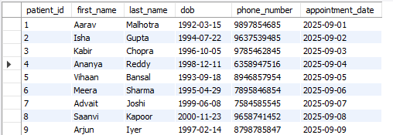
 | INTERPRETATION | 👉 Finds unique patients with recent appointments, helpful for monitoring active patients.

S.no | Business Requirement | Query
2 | List doctors with specialization and patient count | SELECT s.staff_id, s.first_name, s.last_name, s.department AS specialization,  COUNT(DISTINCT a.patient_id) AS patients_treated  FROM staff s  JOIN appointments a ON s.staff_id = a.doctor_id  WHERE s.role = 'Doctor'  GROUP BY s.staff_id, s.first_name, s.last_name, s.department  ORDER BY patients_treated DESC;
 | OUTPUT | 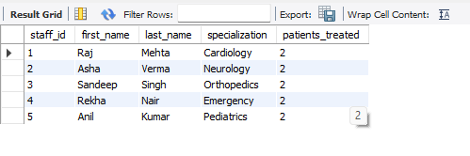
 | INTERPRETATION | 👉 Shows each doctor’s workload and popularity.

S.no | Business Requirement | Query
3 | List Dr. Mehta’s appointments on 15-Mar-2024 with patient details and time. | INSERT INTO appointments (patient_id, doctor_id, appointment_date, appointment_time, status)  VALUES (1, 1, '2024-03-15', '10:00', 'Completed');  SELECT a.appointment_id, CONCAT(p.first_name,' ',p.last_name) AS patient_name,CONCAT(s.first_name, ' ', s.last_name) as doctor_name, a.appointment_date,a.appointment_time  FROM appointments a  JOIN patients p ON a.patient_id = p.patient_id  JOIN staff s ON a.doctor_id = s.staff_id  WHERE s.first_name = 'Raj' AND s.last_name = 'Mehta'  AND a.appointment_date = '2024-03-15'  ORDER BY a.appointment_time;
 | OUTPUT | 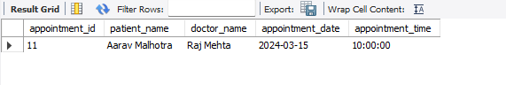
 | INTERPRETATION | 👉 Useful for daily scheduling and appointment verification.

S.no | Business Requirement | Query
4 | List patients admitted more than 10 days with total bill | SELECT p.patient_id, p.first_name, p.last_name,  DATEDIFF(IFNULL(a.discharged_at, CURDATE()), a.admitted_at) AS stay_length,  b.total_amount  FROM admissions a  JOIN patients p ON a.patient_id = p.patient_id  JOIN billing b ON p.patient_id = b.patient_id  WHERE DATEDIFF(IFNULL(a.discharged_at, CURDATE()), a.admitted_at) > 10;
 | OUTPUT | 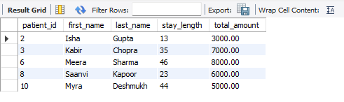
 | INTERPRETATION | 👉 Highlights long-stay patients and ensures billing is accurate.

S.no | Business Requirement | Query
5 | List all available hospital rooms and their current occupancy status | SELECT r.room_id,r.room_number, r.type, r.total_beds,  SUM(CASE WHEN a.discharged_at IS NULL THEN 1 ELSE 0 END) AS occupied_beds,  r.total_beds - SUM(CASE WHEN a.discharged_at IS NULL THEN 1 ELSE 0 END) AS available_beds  FROM rooms r  LEFT JOIN admissions a ON r.room_id = a.room_id  GROUP BY r.room_id, r.room_number, r.type, r.total_beds;
 | OUTPUT | 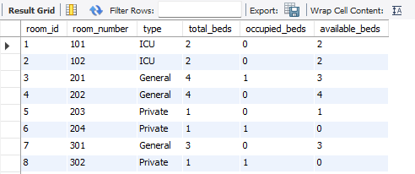
 | INTERPRETATION | 👉 Tracks available vs. occupied beds for resource management.

S.no | Business Requirement | Query
6 | Get full medical history of a patient (illnesses, prescriptions, treatments) | SELECT p.patient_id, p.first_name, p.last_name,  d.illness, d.diagnosis_date,  m.medication_name, pr.start_date, pr.end_date,  t.test_type, t.status AS test_status, t.report_date  FROM patients p  LEFT JOIN diagnoses d ON p.patient_id = d.patient_id  LEFT JOIN prescriptions pr ON p.patient_id = pr.patient_id  LEFT JOIN medications m ON pr.medication_id = m.medication_id  LEFT JOIN tests t ON p.patient_id = t.patient_id  WHERE p.patient_id = '5';
 | OUTPUT
 | INTERPRETATION | 👉 Provides a full case record for better diagnosis and continuity of care.

S.N. | Business Requirement | Query
7 | List last month’s ER visits with reasons and doctors | SELECT e.admission_id, p.first_name, p.last_name, e.admitted_at, concat(s.first_name,' ', s.last_name)AS doctor  FROM admissions e  JOIN patients p ON e.patient_id = p.patient_id  JOIN staff s ON e.doctor_id = s.staff_id  WHERE s.department = 'Emergency'  AND e.admitted_at >= CURRENT_DATE - INTERVAL 1 month;
 | OUTPUT | 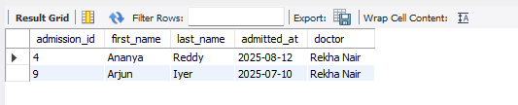
 | INTERPRETATION | 👉 Tracks urgent cases, reasons, and attending doctors.

S.N. | Business Requirement | Query
8 | List patients prescribed Amoxicillin in last 3 months. | SELECT DISTINCT p.patient_id, p.first_name, p.last_name  FROM prescriptions pr  JOIN medications m ON pr.medication_id = m.medication_id  JOIN patients p ON pr.patient_id = p.patient_id  WHERE m.medication_name LIKE 'Amoxicillin'  AND pr.start_date >= CURRENT_DATE - INTERVAL 3 month;
 | OUTPUT | 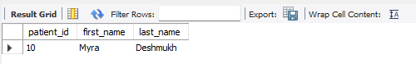
 | INTERPRETATION | 👉 Helps monitor antibiotic usage and prescriptions.

S.N. | Business Requirement | Query
9 | List pending test reports with type and delivery date | SELECT  t.test_id,p.first_name,p.last_name,t.test_type, t.ordered_date,  t.expected_report_date  FROM tests t  JOIN patients p ON t.patient_id = p.patient_id  WHERE t.status = 'Pending';
 | OUTPUT | 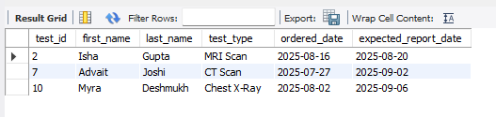
 | INTERPRETATION | 👉 Ensures timely follow-ups and avoids missed results.

S.N. | Business Requirement | Query
10 | Find department with most admissions in last year | SELECT s.department, COUNT(*) AS admission_count  FROM admissions a  JOIN staff s ON a.doctor_id = s.staff_id  WHERE a.admitted_at >= CURRENT_DATE - INTERVAL 1 year  GROUP BY s.department  ORDER BY admission_count DESC limit 1;
 | OUTPUT | 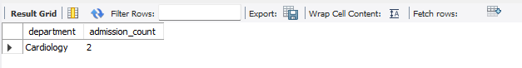
 | INTERPRETATION | 👉 Identifies busiest department for planning staff and resources.

S.N. | Business Requirement | Query
11 | List patients who saw multiple doctors for same illness. | SELECT p.patient_id, p.first_name, p.last_name, d.illness,  COUNT(DISTINCT d.doctor_id) AS doctor_count  FROM diagnoses d  JOIN patients p ON d.patient_id = p.patient_id  GROUP BY p.patient_id, p.first_name, p.last_name, d.illness  HAVING COUNT(DISTINCT d.doctor_id) > 1;
 | OUTPUT | 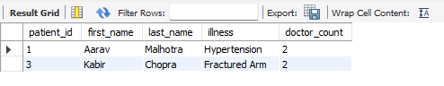
 | INTERPRETATION | 👉 Detects second opinions or referral patterns.

S.N. | Business Requirement | Query
12 | List Cardiology staff with roles and shift timings | ALTER TABLE staff ADD COLUMN shift_time VARCHAR(20) CHECK (shift_time IN ('Morning', 'Evening', 'Night')) DEFAULT 'Morning';  UPDATE staff SET shift_time='Morning' WHERE staff_id IN (1,6,9);  UPDATE staff SET shift_time='Evening' WHERE staff_id IN (2,7,10);  UPDATE staff SET shift_time='Night' WHERE staff_id IN (3,4,5,8);  SELECT staff_id, first_name, last_name, role, department, shift_time  FROM staff  WHERE department = 'Cardiology';
 | OUTPUT | 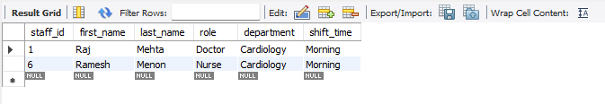
 | INTERPRETATION | 👉 Useful for staff duty rosters and availability checks.

S.N. | Business Requirement | Query
13 | Count surgeries in last 6 months by type | SELECT d.illness AS surgery_type, COUNT(*) AS surgery_count  FROM diagnoses d  WHERE d.illness LIKE '%surgery%'  AND d.diagnosis_date >= CURRENT_DATE - INTERVAL 6 month GROUP BY d.illness;
 | OUTPUT | 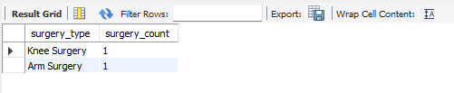
 | INTERPRETATION | 👉 Tracks surgical workload and common surgery trends.

S.N. | Business Requirement | Query
14 | List prescriptions by a doctor in a date range | SELECT pr.prescription_id, m.medication_name,CONCAT(p.first_name,' ',p.last_name) AS patient_name, pr.start_date  FROM prescriptions pr  JOIN medications m ON pr.medication_id = m.medication_id  JOIN patients p ON pr.patient_id = p.patient_id  WHERE pr.doctor_id = (SELECT staff_id FROM staff WHERE first_name='Asha' AND last_name='Verma')  AND pr.start_date BETWEEN '2025-01-01' AND '2025-09-08';
 | OUTPUT | 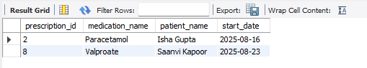
 | INTERPRETATION | 👉 Used for prescription audits or doctor performance tracking.

S.N. | Business Requirement | Query
15 | Identify the most commonly diagnosed illness based on patient records | SELECT illness, COUNT(*) AS frequency  FROM diagnoses  GROUP BY illness  ORDER BY frequency DESC  LIMIT 1;
 | OUTPUT | 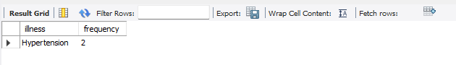
 | INTERPRETATION | 👉 Reveals health trends and common conditions treated.

S.N. | Business Requirement | Query
16 | Report hospital revenue from consultations, surgeries, and tests | SELECT SUM(total_amount) AS total_revenue FROM billing;
 | OUTPUT | 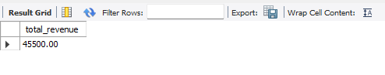
 | INTERPRETATION | 👉 Summarizes financial performance.

S.N. | Business Requirement | Query
17 | On discharge, update final bill with consultation, treatment, and room charges | DELIMITER $$  CREATE TRIGGER update_final_bill_on_discharge  AFTER UPDATE ON admissions  FOR EACH ROW  BEGIN  DECLARE stay_days INT;  IF NEW.discharged_at IS NOT NULL THEN  SET stay_days = DATEDIFF(NEW.discharged_at, NEW.admitted_at);  UPDATE billing  SET total_amount = total_amount + (stay_days * 1000) -- Example: ₹1000/day room charge  WHERE patient_id = NEW.patient_id;  END IF;  END$$  DELIMITER ;
 | OUTPUT | 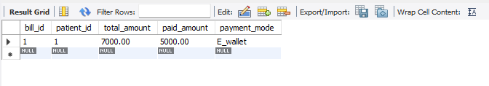
 | INTERPRETATION | Ensures billing accuracy upon discharge.

S.N. | Business Requirement | Query
18 | Auto-notify doctors if critical patient vitals fall below safe level. | DELIMITER $$  CREATE TRIGGER alert_critical_vitals  AFTER INSERT ON vitals  FOR EACH ROW  BEGIN  IF NEW.heart_rate < 40 OR NEW.bp_systolic < 80 THEN  INSERT INTO alerts (patient_id, alert_message, created_at)  VALUES (NEW.patient_id, 'Critical vitals! Notify doctor immediately.', NOW());  END IF;  END$$  DELIMITER ;
 | OUTPUT | 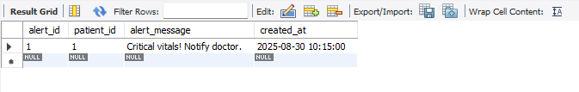
 | INTERPRETATION | 👉 Supports real-time monitoring of critical patients.

S.N. | Business Requirement | Query
19 | Prevent duplicate patient records on registration. | ALTER TABLE patients  ADD UNIQUE KEY uniq_patient_name_dob (first_name, last_name, dob);
 | OUTPUT | 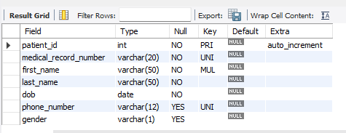
 | INTERPRETATION | 👉 Ensures clean and consistent patient database.

S.N. | Business Requirement | Query
20 | Update room availability on patient admission/discharge | DELIMITER $$  CREATE TRIGGER update_room_status_on_admit  AFTER INSERT ON admissions  FOR EACH ROW  BEGIN  UPDATE rooms  SET is_available = FALSE  WHERE room_id = NEW.room_id;  END$$  DELIMITER ;  -- When discharged - mark room available again  DELIMITER $$  CREATE TRIGGER update_room_status_on_discharge  AFTER UPDATE ON admissions  FOR EACH ROW  BEGIN  IF NEW.discharged_at IS NOT NULL THEN  UPDATE rooms  SET is_available = TRUE  WHERE room_id = NEW.room_id;  END IF;  END$$  DELIMITER ;
 | OUTPUT | 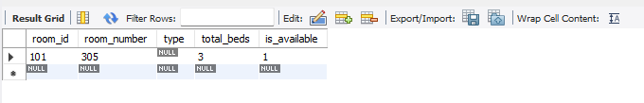
 | INTERPRETATION | 👉 Keeps bed status updated automatically.

S.N. | Business Requirement | Query
21 | Check pharmacy stock before issuing medications | DELIMITER $$  CREATE TRIGGER check_medication_stock  BEFORE INSERT ON prescriptions  FOR EACH ROW  BEGIN  DECLARE stock INT;  SELECT stock_qty INTO stock  FROM pharmacy_inventory  WHERE medication_id = NEW.medication_id;  IF stock IS NULL OR stock <= 0 THEN  SIGNAL SQLSTATE '45000'  SET MESSAGE_TEXT = 'Medication not available in stock!';  END IF;  END$$
 | OUTPUT
 | INTERPRETATION | 👉Prevents issuing prescriptions for unavaible medicines

S.N. | Business Requirement | Query
22 | Restrict modification/deletion of patient records to authorized staff | CREATE ROLE medical_admin;  GRANT SELECT, INSERT, UPDATE, DELETE ON patients TO medical_admin;  REVOKE UPDATE, DELETE ON hospital.patients FROM 'guest_user'@'localhost';
 | OUTPUT
 | INTERPRETATION | 👉 Strengthens data security and privacy.

S.N. | Business Requirement | Query
23 | Alert if patient misses follow-up appointment. | SET GLOBAL event_scheduler=ON;  DELIMITER $$  CREATE EVENT missed_followup_alert  ON SCHEDULE EVERY 1 day  DO  INSERT INTO alerts (patient_id, alert_message, created_at)  SELECT a.patient_id, 'Missed follow-up appointment', NOW()  FROM appointments a  WHERE a.status = 'Scheduled'  AND a.appointment_date < CURDATE();  END $$  DELIMITER ;
 | OUTPUT | 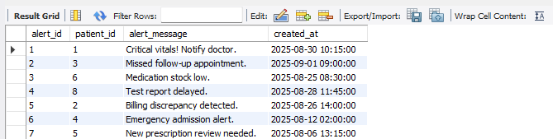
 | INTERPRETATION | 👉 Helps reduce no-shows and ensures continuity of care.

S.N. | Business Requirement | Query
24 | Auto-update inventory on supply receipt or usage | DELIMITER $$  CREATE TRIGGER update_inventory_on_usage  AFTER INSERT ON prescriptions  FOR EACH ROW  BEGIN  UPDATE pharmacy_inventory  SET stock_qty = stock_qty - 1  WHERE medication_id = NEW.medication_id;  END$$  DELIMITER ;
 | OUTPUT | 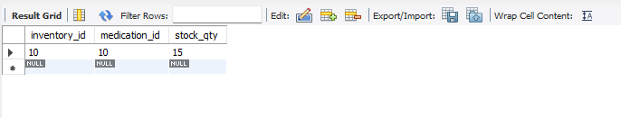
 | INTERPRETATION | 👉 Maintains real-time stock levels.

S.N. | Business Requirement | Query
25 | Monthly report of admissions, treatments, and trends | DELIMITER $$  CREATE TRIGGER update_inventory_on_usage  AFTER INSERT ON prescriptions  FOR EACH ROW  BEGIN  UPDATE pharmacy_inventory  SET stock_qty = stock_qty - 1  WHERE medication_id = NEW.medication_id;  END$$
 | OUTPUT | 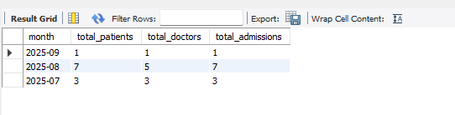
 | INTERPRETATION | 👉 Provides hospital performance overview by month.

S.N. | Business Requirement | Query
26 | Update final bill on discharge with consultation, treatment, and room charges | DELIMITER $$  CREATE TRIGGER trg_update_final_bill  AFTER UPDATE ON admissions  FOR EACH ROW  BEGIN  IF NEW.discharged_at IS NOT NULL THEN  UPDATE billing  SET total_amount = total_amount  + ((SELECT total_beds FROM rooms WHERE room_id = NEW.room_id) * 1000)  WHERE patient_id = NEW.patient_id;  END IF;  END $$  DELIMITER ;
 | OUTPUT | 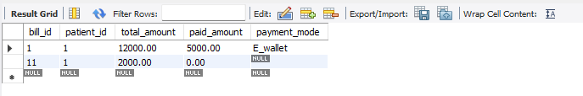
 | INTERPRETATION | 👉 Alternative billing calculation ensuring cost recovery.

CONCLUSION

The Hospital Patient Management System (HPMS) successfully addresses the challenges faced by hospitals that rely on manual or outdated processes. By centralizing patient records, appointments, billing, diagnostics, and inventory management into a secure and integrated database, the system enhances efficiency, reduces errors, and ensures real-time access to critical information. Automated triggers and alerts further strengthen patient safety, resource utilization, and staff coordination.
Overall, HPMS not only streamlines hospital operations but also improves the quality of healthcare services delivered to patients. With its scalability and adaptability, the system can be expanded to support future advancements and evolving healthcare needs, making it a reliable and sustainable solution for modern hospitals

